**Figure 1**

*Student socioeconomic status*

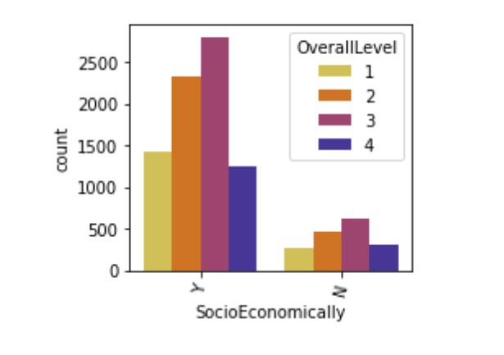

**Figure 2**

*Student housing status*

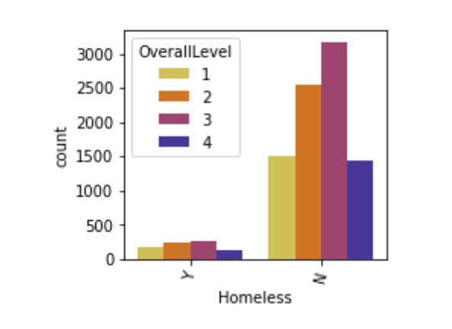

**Table 1**

*Student housing status breakdown*

|  |  |  |
| --- | --- | --- |
| Overall Level | Homeless (%) | Not Homeless (%) |
| 1 | .106 | .893 |
| 2 | .086 | .914 |
| 3 | .926 | .074 |
| 4 | .923 | .077 |